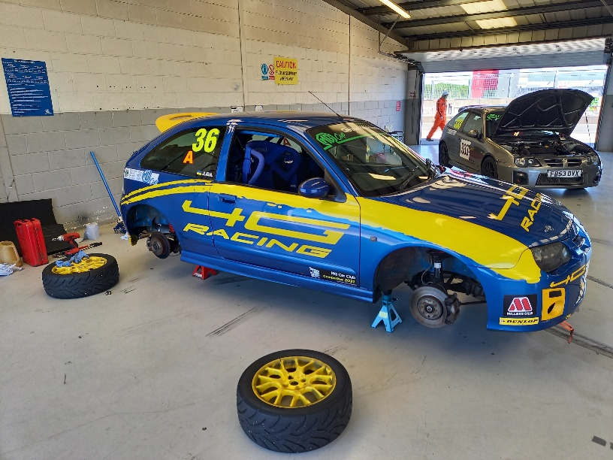

For Sale my MG ZR 160 RACE CAR / TRACK DAY CAR, It is the 2015 MG Trophy Championship out right winning car was built and maintained for me by 4G racing and has many class wins, fastest laps and pole positions to 2022 in the MG Trophy Championship and MG Cup Championship and would be eligible for many other championships / race series to race, it will require a fire extinguisher service it will come with 3 spare full sets of wheels and tyres, it is a race car and has a few minor scuffs.
- Safety Devices Bolt in Roll cage
- TRS Harness (in date to end of year)
- Fireline zero 2000 Fire extinguisher (will need a new one out of date on age)
- Odyssey race battery
- Wheels and Tyres Full set Dunlop Direz 036 on car, Full set Uniroyal Rainsport 3, Full set Yokohama Parada spec 2, Full set Toyo Proxes T1 R
For more information regarding the car do not hesitate to get in touch the car is located in Wolverhampton no time wasters or tyre kickers please payment cash / bank transfer £3,750.00

Contact John 07506 608077
