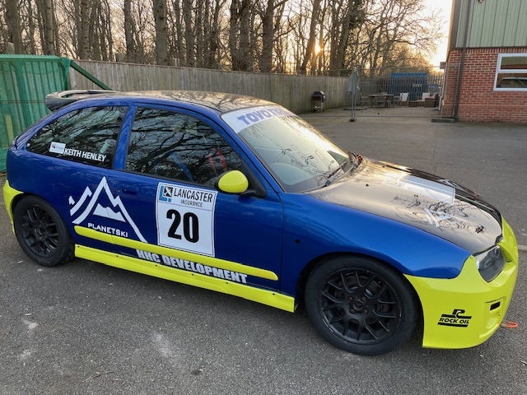
MG ZR 170 Race Car FOR SALE £5,750.00
This car has raced in both the MGCC Trophy Championship and the MGOC Championship.
The car will come with a set of used TOYO TYRES
and a set of unused TOYO TYRES on wheels.
The car is race ready,1.8 vvc 170 (mapped ECU)
engine with a Paul Streather motorsport head.
Uprated light fly wheel and AP racing clutch kit.
It has a mk 1 loom and the championship 170 mapped ecu. Gearbox and engine sealed.ITG induction kit with
front pick up kit.
It has a 6-point bolt in safety device roll cage with double door bars, weld in seat rails both sides. Comes with two racing seats and belts.
Plumbed in extinguisher. Full in car braided brake line
with bias valve. It has Gaz gold coilovers with adjustable top mounts on the front and camber shims to the rear.
Powerflex bushes all round and gear selector bush kit.
Uprated front hub flanges and the car is seam welded front to back.
We have a spare door, boot and a front bumper!
Contact Keith on 07860 694108 or keith.henley@rvinall.co.uk

